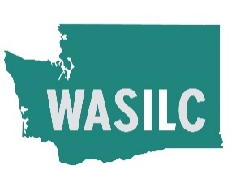

**CIEP ALERT**

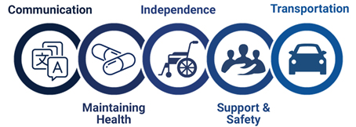

**Spring**

**2023**

**MEET CIEP IN ST. LOUIS!**

# Planning for Accessible AWN Messages and Systems

Ms. Donna Platt, North Carolina Department of Health and Human Services, Division of Services for the Deaf and Hard of Hearing [and former 9-1-1 TTY (Text Telephone) Trainer for Washington State.], and Mr. Jim House, Coalition on Inclusive Emergency Planning (CIEP), Washington State presented on considerations for accessible AWN (Alerts, Warnings, & Notifications) messages and systems. They provided historical background of accessible alerting, demographics of Americans with disabilities, and how EAS (Emergency Alerting System) and WEA (Wireless Emergency Alerts) currently supports the deaf and hard of hearing community.

Ms. Platt and Mr. House demonstrated how for the Deaf and Hard of Hearing community, audio only AWN messages should be paired with a visual or vibrational element to ensure that recipients will be alerted to the hazard. Text-to-speech applications work for the low vision and blind community, however different technology should be utilized for other communities with disabilities. It was recommended to keep WEA message short and concise, with graphics, visual symbols, pictures, as well as with clean, trustworthy URL (Universal Resource Locater) linking to additional information, such as premade videos of American Sign Language (ASL) interpretation of the AWN. Ms. Platt and Mr. House cautioned that there are a variety of sign languages and there are also colloquialisms to each of them. It was reinforced that the suggestion of working with local communities to maintain a list of qualified signers to produce AWN as needed. Mr. House suggested for the WEA messages to include a map or a snapshot of the polygon, so the recipients are more aware of the location of the hazard in relation to them. Furthermore, the presenters challenged the standard practice of audible, visual, and vibrational AWN message. They asked participants and meeting sponsors to consider whether the typical AWN message could lead the recipients into dangerous situations where an individual may need to keep their locations concealed (e.g., domestic violence, mass casualty event).

To improve EAS accessibility, the presenters noted that the caption and audio need to be in-sync, and the crawl text should also be synced to an appropriate speed. Strong contrast colors should also be used to improve readability of crawl text. [Here is a tool to help verify contrast colors at [Web Aim’s Contrast Checker](https://gcc02.safelinks.protection.outlook.com/?url=https%3A%2F%2Fwebaim.org%2Fresources%2Fcontrastchecker%2F&data=05%7C01%7Cjim.house%40dshs.wa.gov%7C67b910eb3cd04921f94f08db65f9b3bd%7C11d0e217264e400a8ba057dcc127d72d%7C0%7C0%7C638215895350126147%7CUnknown%7CTWFpbGZsb3d8eyJWIjoiMC4wLjAwMDAiLCJQIjoiV2luMzIiLCJBTiI6Ik1haWwiLCJXVCI6Mn0%3D%7C3000%7C%7C%7C&sdata=UvZztS2kcvQRAcMn192c%2FRrXSCYgCIj6cxeUEpwgiXY%3D&reserved=0)] They asked participants to consider how to best alert the portion of the public not opting for cable or satellite-based TV services. Presenters also reviewed how the National Oceanic and Atmospheric Administration’s (NOAA) weather alert radio and alerting devices work for communities with disabilities. Presenters also suggested that device displays be updated so that more information can be shown with improved readability and brightness.

Ms. Platt and Mr. House emphasize the importance of testing all devices for effectiveness and accessibility and asked participants to include recipients with disabilities and other access and functional needs in future AWN test and exercise plans to ensure that AWN messages are reaching the whole community. Other future accessible AWN considerations include developing cadence to override the “Do Not Disturb”, adding more visible strobes to outdoor systems, using avatars for ASL (American Sign Language) alerts, and other ways to incorporate alerting into streaming and other next generation platforms.

During the Question & Answer session, [Dr. Jeanette Sutton, Director of the Emergency and Risk Communication Message Testing Lab at the State University of New York in Albany,] discussed the usage of earthquake early warning applications for the public living on the West Coast. Mr. Wiley explained that the FCC (Federal Communications Commission) recently proposed the requirement for providers to record the coordinates and work with device-native mapping applications to allow for the display of maps in WEA messages. Participants then discussed sending WEA without vibration during the COVID pandemic to avoid alert fatigue. It may be beneficial to educate the public on how to adjust the WEA vibration and audio settings.

[from meeting presentation notes circulated to participants.]

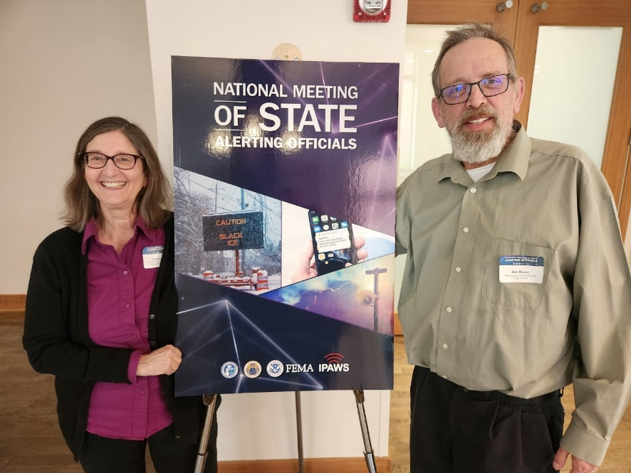

Donna Platt and Jim House standing by a sign for NATIONAL MEETING OF STATE ALERTING OFFICIALS in St. Louis

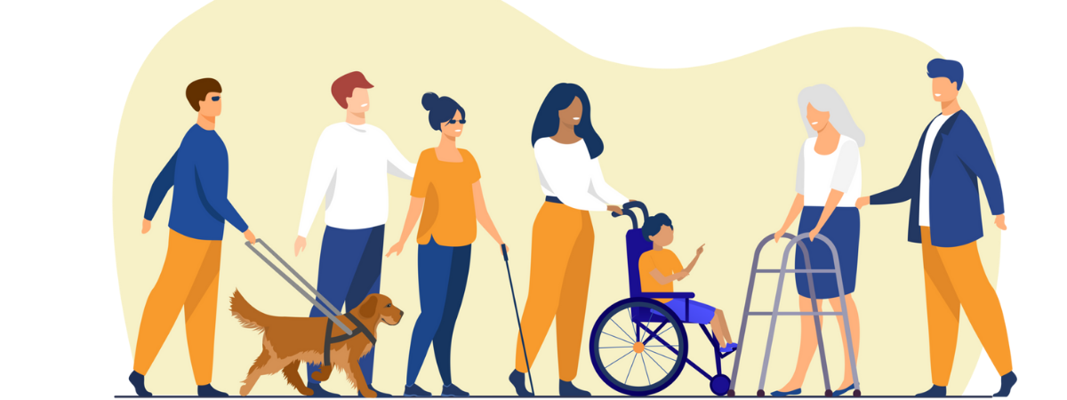

# DEB’S ENERGY STRATEGY FOR AFN IN WASHINGTON

**Deborah Witmer**

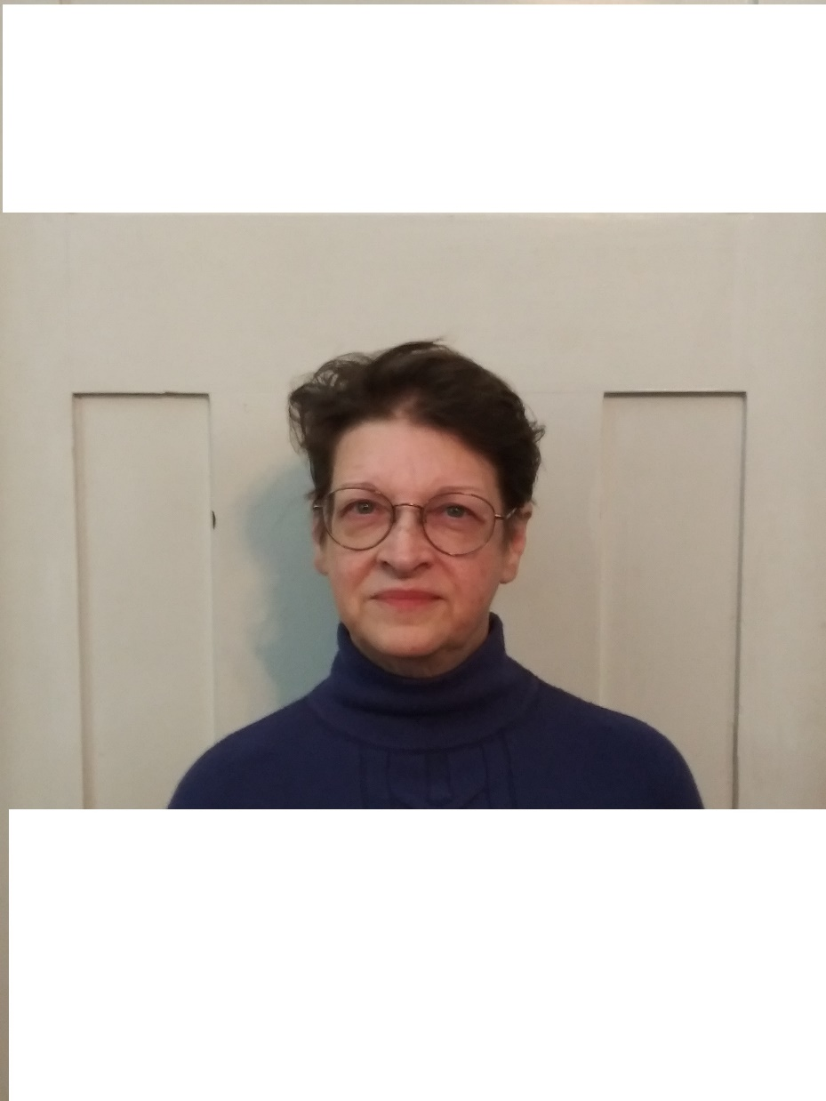

Deborah (Deb) Witmer serves as the Energy Resilience & Mitigation Program Manager in the Energy Resilience and Emergency Management Office (EREMO), part of the Washington State Department of Commerce’s Energy Division. In that role, she is leading a team to build a (first in the nation) state-wide Energy Resilience Program, including the design of a Whole Community Resilience Planning Process. Deb brings to her work many years of public outreach and engagement experience, particularly with vulnerable populations, including those with access and functional needs. Her other areas of expertise include emergency management, community planning, meeting facilitation, program development, training and exercise development and delivery, and public speaking. She holds a Bachelor of Arts (BA) degree in Communications from Kent State University as well as a Master of Sciences (MS) degree in Security Studies from the Naval Postgraduate School/Center for Homeland Defense and Security (NPS/CHDS). She brings a passion for energy resilience and whole community to her work with the State of Washington. Deborah lives in Seattle with her two cats and an overstuffed art studio space.

## CIEP: I understand you were with the City of Seattle Human Services before you came to this position. How did you select this field?

**Deb:** I have been interested in resilience issues for many years – and energy underpins almost everything we do today. Without dependable energy sources, disaster response and recovery could be severely impacted. This position offered me an opportunity to develop a new program – the first one the nation, in fact – supporting energy resilience and centering vulnerable populations in its work. In emergency management, we define vulnerable populations as “those who are disproportionally impacted by disaster.” I have always believed that means vulnerable populations should get disproportionately more of the resources. This new program is a chance to put that belief into action.

## CIEP: Have you personally experienced a disaster, what was it like?

**Deb:** I was born in California and have been told I experienced an earthquake there, but I was too young to have memory of it! <smile> I have been lucky, although I did emergency response in Seattle for several years with severe winter weather – and then the heat dome 2 years ago. But COVID had the most impact to me personally. With people in my life who are immune-compromised, I basically quarantined for 17 months and worked the City’s emergency response from home. Very stressful time, but I came through and was lucky not to lose any close friends or family due to illness. That experience taught me the true value of an organized – and inclusive - disaster response.

## CIEP: Knowing that the Americans with Disabilities Act (ADA) and other accessibility laws and regulations remain in full effect during disasters, what gaps have you seen in the field of emergency planning here in the state?

**Deb:** More gaps than I can count, unfortunately. There is still a large group of folks who have misguided and (frankly) biased ideas about people with disabilities. We are NOT sitting around waiting to be rescued! I have always said people with disabilities are the most creative people you will ever meet. Every single day, we are faced with multiple barriers we must overcome with few resources and little help. If emergency planners would just open seats for us to meaningfully participate in their work – *and be open to new ideas* – we can change outcomes for everyone. Universal Design for Emergency Management!  
  
Honestly, emergency communications that reach everyone of all abilities at the same time – with actionable information – is sadly lacking. Shelters, heating/cooling centers, feeding operations, points of distribution for critical supplies, even medical services are often not set up in accessible locations or buildings. American Sign Language (ASL) and other language interpretation is usually not provided for community meetings or at service locations. And this is not just true in smaller, more under-resourced communities. King County and the City of Seattle, for example, still have a long way to go in consistently meeting ADA requirements. I think what we often see is that a jurisdiction has one (or 2) “ADA champions” who work to meet Access and Functional Needs (AFN) needs. When they leave their agencies, that work often ends. We MUST build sustainable, inclusive capabilities in our emergency management programs. It must be built into the DNA of the work. It should start with the planning process.

## CIEP: What are some of the best practices have you noticed in inclusive emergency planning around Washington before, during, and after COVID?

**Deb:** As COVID began to impact our state, the King County Disability Coalition (KCDC) came together in reaction to a complete lack of attention to access and functional needs in the COVID response. Comprised of over 40 organizations and 200 individual supporters and advocates, the group met to organize direct action, pressuring King County leadership to address this critical gap. And they were wildly successful! Money was added to budgets, and ADA expertise added to the King County equity office. KCDC has been providing educational opportunities, additional advocacy, and political pressure to continue the progress towards meeting the needs of people with disabilities 365 days of the year (not just in disasters!) Having worked in this space for more than 30 years, I have never seen such success; their playbook should become a best practice.  
  
I think the City of Seattle, in their COVID response, also set a high bar for providing accessible testing and vaccination services. Working directly with the DeafBlind community (people with lived experience), the City’s AFN COVID Response Team developed a written plan to ensure that people of all abilities could independently access COVID testing (and later vaccination) services at City-sponsored sites. It was initially tested by successfully providing services at a neighborhood clinic to 10 people who are DeafBlind, during a very busy Saturday. This work and learning led to a written COVID testing site ADA access plan that was widely adopted in Washington and was incorporated into national guidance from FEMA (Federal Emergency Management Agency). None of this would have been possible without the direct involvement of people with lived experience in the planning process. I think this proved (without a doubt) the value of inclusive emergency planning.

## CIEP: Now that you have been with the Washington Department of Commerce (DOC) for a few months, what priorities do you envision for 2023 and beyond for AFN and DOC’s impact on stakeholders across the state?

**Deb:** I am excited for two reasons: First, being able to support the Coalition (CIEP) and other disability advocates and groups in connecting with all the community-supportive programs and funding here at Commerce. Our department is working in some very critical spaces, like housing, broadband access, childcare, and, of course, energy resilience and climate change <smile>. People with Access and Functional Needs should be a part of all that work in order to ensure the benefits are available to everyone equally. I have been excited to hear about new AFN partnerships around broadband access, for example – an important resource that everyone needs access to in today’s world. CIEP is really leading the way in addressing all the interconnected issues that impact people with disabilities in disasters. I am so honored to be a part of this work!  
  
And secondly – and in part due to CIEP’s support – I have come to realize the value of having a person with lived disability experience as part of the Commerce staff. I am advocating - from the “inside” – for accessibility and ADA-compliance for both the public and employees with disabilities. My very first day, I received a new PowerPoint (PPT) template we are supposed to use – and I sent it back to the communications team because it wasn’t accessible to me (with my visual disabilities). I was pleasantly surprised that they went right to work adding alt text and addressing other screen reader issues! I have experienced that there is a renewed recognition of our state’s ADA obligations, and more and more work is being done to address gaps. I am also very appreciative of my leadership’s support; my team has the budget and technology we need to do our work as accessibly as possible – we are setting a high bar for inclusive public outreach and engagement!

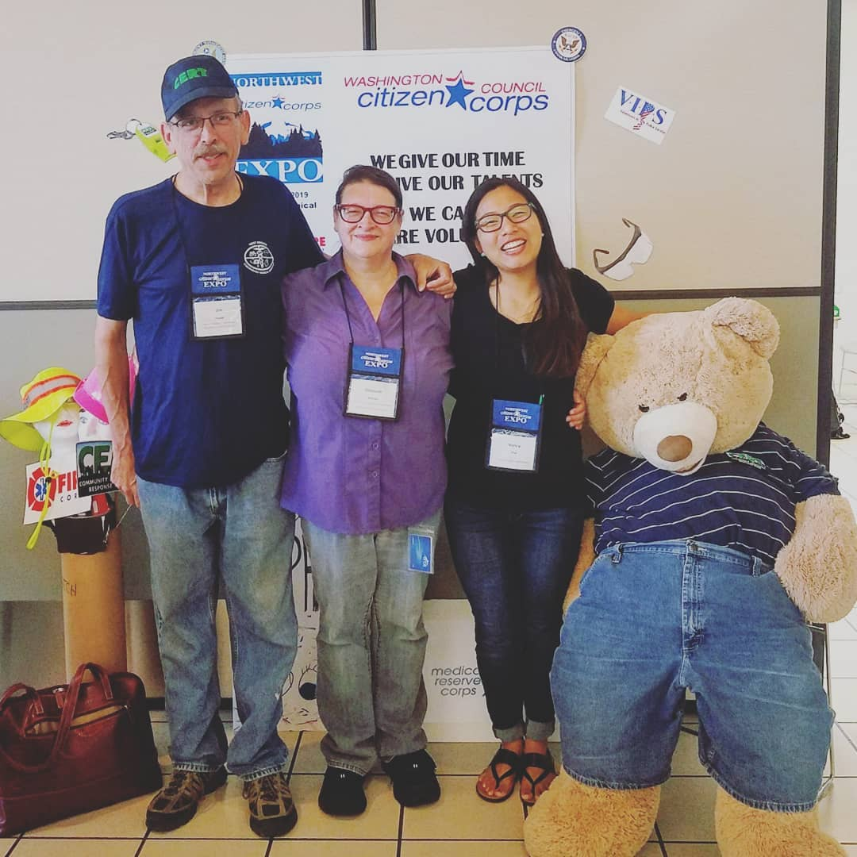

Jim House, Deb Witmer, Nancy Thai, and "Ted Bear" after AFN Training at CERT Citizens Expo at Renton Technical College in 2019.

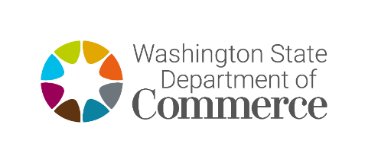

**Contact:** Deb Witmer (She/Her)

Energy Resilience and Mitigation Program Manager,

Energy Resilience and Emergency Management Office (EREMO)

WA Department of Commerce

Deborah.Witmer@commerce.wa.gov

# 

# WILDFIRE SMOKE/AIR QUALITY RESOURCES

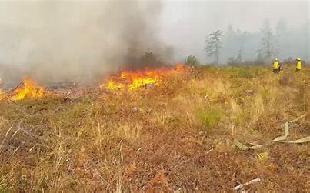We are now entering the 2023 wildfire season. It came a bit earlier this year because of all the fires burning in Alberta, that is causing all the smoke to drift from Canada down to Washington State. Fortunately, most of the smoke is in the upper levels of the atmosphere with little impact on ground level air quality in Western Washington. However, Central and Eastern Washington are bearing the brunt of degraded air quality.

CIEP has recently engaged with a new partner, Marnie Boardman who is the Climate Health Coordinator at the Office of Environmental Public Health Sciences at the Washington Department of Health (DOH). Below are some resources that she shared with the CIEP Advisory Group in a recent email.

* [Washington Smoke Information (wasmoke.blogspot.com)](https://gcc02.safelinks.protection.outlook.com/?url=https%3A%2F%2Fwasmoke.blogspot.com%2F&data=05%7C01%7Cjim.house%40dshs.wa.gov%7Cd252f6ef4f6941d028e208db5c963d77%7C11d0e217264e400a8ba057dcc127d72d%7C0%7C0%7C638205572572061568%7CUnknown%7CTWFpbGZsb3d8eyJWIjoiMC4wLjAwMDAiLCJQIjoiV2luMzIiLCJBTiI6Ik1haWwiLCJXVCI6Mn0%3D%7C3000%7C%7C%7C&sdata=1TMhEJsNMTpYyIJ4yrDxnUv5FotRdgSbJpZTPJ9Msf8%3D&reserved=0) – see the Health tab
* [Smoke From Wildfires - Toolkit | Washington State Department of Health](https://gcc02.safelinks.protection.outlook.com/?url=https%3A%2F%2Fdoh.wa.gov%2Fcommunity-and-environment%2Fair-quality%2Fsmoke-fires%2Fsmoke-wildfires-toolkit&data=05%7C01%7Cjim.house%40dshs.wa.gov%7Cd252f6ef4f6941d028e208db5c963d77%7C11d0e217264e400a8ba057dcc127d72d%7C0%7C0%7C638205572572061568%7CUnknown%7CTWFpbGZsb3d8eyJWIjoiMC4wLjAwMDAiLCJQIjoiV2luMzIiLCJBTiI6Ik1haWwiLCJXVCI6Mn0%3D%7C3000%7C%7C%7C&sdata=TFdnLYlqdVwLI54Iq2UkfFaWKFzOzDqopfHCSjMksvE%3D&reserved=0) This toolkit includes recommendations for [Wildfire Smoke and COVID-19](https://gcc02.safelinks.protection.outlook.com/?url=https%3A%2F%2Fdoh.wa.gov%2Fsites%2Fdefault%2Ffiles%2Flegacy%2FDocuments%2FPubs%2F821-144.pdf%3Fuid%3D6278e859afce5&data=05%7C01%7Cjim.house%40dshs.wa.gov%7Cd252f6ef4f6941d028e208db5c963d77%7C11d0e217264e400a8ba057dcc127d72d%7C0%7C0%7C638205572572061568%7CUnknown%7CTWFpbGZsb3d8eyJWIjoiMC4wLjAwMDAiLCJQIjoiV2luMzIiLCJBTiI6Ik1haWwiLCJXVCI6Mn0%3D%7C3000%7C%7C%7C&sdata=6vKD83Bo5NPFtz1P6tOq2hAvfv8u%2FDZcXx3yl6S%2F8qM%3D&reserved=0), among other tools and guidance.

**More resources in the toolkit (Multiple languages also available for some publications):**

* [Washington Air Quality Guide for Particle Pollution](https://doh.wa.gov/sites/default/files/legacy/Documents/4300/waqa%20infographic_English.pdf?uid=646e71a441aaa)
* [Washington Air Quality Guide for School Child Care Activities](https://doh.wa.gov/sites/default/files/legacy/Documents/Pubs/334-332.pdf?uid=646e71a4473e1)
* [Washington Guide for Public Health Actions for Wildfire Smoke](https://doh.wa.gov/sites/default/files/legacy/Documents/4300/334-429-WAQAGuidePublicHealthActions.pdf?uid=6278e859bc4b4)
* [Wildfire Smoke Guidance for Canceling Outdoor Events or Activities and Closing Schools](https://doh.wa.gov/sites/default/files/legacy/Documents/4300/334-428-WildfireSmokeClosureGuidance_final3.pdf?uid=646e71a448071)
  + [Summary Wildfire Smoke Guidance for Cancelling Outdoor Public Events or Activities](https://doh.wa.gov/sites/default/files/legacy/Documents/4300/334-430-WIldfireSmokeOUTDOORSummary.pdf?uid=646e71a44875c)
  + [Summary Wildfire Smoke Guidance for Closing Schools](https://doh.wa.gov/sites/default/files/legacy/Documents/4300/334-431-WIldfireSmokeSCHOOLSummary.pdf?uid=646e71a448c54)
* [Recommendations for Wildfire Smoke and COVID-19](https://doh.wa.gov/sites/default/files/legacy/Documents/Pubs/821-144.pdf?uid=646e71a449231)
* [Washington State CEMP ESF 8 Attachment 1 to Appendix 5 – Wildfire Response – Severe Smoke Episodes](https://doh.wa.gov/sites/default/files/legacy/Documents/4300/ESF8-Appendix5-Att1-SevereSmokeEpisodes.pdf?uid=646e71a4496ef)
* [Smoke from fires can be dangerous](https://doh.wa.gov/sites/default/files/legacy/Documents/4300/Smoke_sensitive%20populations%20Everyone_English.pdf?uid=646e71a449bce) **flyers:**
  + [For babies and children](https://doh.wa.gov/sites/default/files/legacy/Documents/4300/Smoke_sensitive%20populations%20Babies%20and%20Children_English.pdf?uid=646e71a44d942)
  + [For pregnant people](https://doh.wa.gov/sites/default/files/legacy/Documents/4300/Smoke_sensitive%20populations%20Pregnant_English.pdf?uid=646e71a44e4e7)
  + [For people over 65](https://doh.wa.gov/sites/default/files/legacy/Documents/4300/Smoke_sensitive%20populations%20Over%2065_English.pdf?uid=646e71a45221f)
  + [For people with lung and heart diseases](https://doh.wa.gov/sites/default/files/legacy/Documents/4300/Smoke_sensitive%20populations%20Heart%20and%20Lung_English.pdf?uid=646e71a455bfb)
* [Face mask fact sheet](https://doh.wa.gov/sites/default/files/legacy/Documents/Pubs/334-353.pdf?uid=646e71a4571fc)
* [WA Smoke Blog Website](http://wasmoke.blogspot.com/)  This site provides a wide range of timely information, including wildfire status updates, air quality conditions and forecasts, and health information.
* [WA Labor & Industries Wildfire Smoke website](https://lni.wa.gov/safety-health/safety-topics/topics/wildfire-smoke?utm_medium=email&utm_source=govdelivery) For information on wildfire smoke and outdoor worker safety, including workplace requirements and policies.

## ****WILDFIRE INFORMATION FROM THE WASHINGTON DEPARTMENT OF NATURAL RESOURCES (DNR)****

[Current Wildfire Incident Information | WA - DNR](https://www.dnr.wa.gov/Wildfires)

* Check the DNR [Burn Risk Map](https://fortress.wa.gov/dnr/protection/firedanger/) for current fire danger in your county.
* Use our recreation map and click through to site-specific information on campgrounds or recreation sites closed due to wildfires.
* The cause of a fire being [investigated](https://www.dnr.wa.gov/Investigations) by DNR may be available quickly, or may take several months, depending on complexity.
* Please check [burn restrictions](https://www.dnr.wa.gov/OutdoorBurning) before lighting any fire.

# COMING EVENTS:

**CIEP Stakeholder Calls (AFN Response to Disasters)   
WHEN: Monthly on first Wednesday at 10:00-11:00 am.**   
**WHERE:** **Zoom link** for monthly calls thru December 2023.  
Email [**Jim.House@dshs.wa.gov**](mailto:housej@dshs.wa.gov?subject=CIEP%20Meeting%20Information) for details and agenda.

### **WASILC Quarterly Meetings WHEN: Thursday, July 13 & Friday, July 14, 2023 WHERE:** [**Central Washington Disability Resources**](https://www.mycwdr.org/)— Ellensburg / Remote Zoom option available — Email [**WASILC@dshs.wa.gov**](mailto:ramsejt@dshs.wa.gov?subject=WASILC%20Quarterly%20Meeting%20Inquiry) for details.

All CIEP Stakeholder Calls and WASILC Quarterly Meetings are open to everyone. ASL interpreters and CART will be provided. For other reasonable accommodation requests, please email us as early as possible.

# About CIEP:

CIEP is a statewide advisory group that brings expertise into disaster planning based on access and functional needs (AFN) faced by people with disabilities in three areas: **1)** Effective Communications, **2)** Programmatic Access, and **3)** Physical Access. We welcome any suggestions for future issues of the quarterly **CIEP ALERT** newsletter.

**Jim House, Disability Integration Manager  
Coalition on Inclusive Emergency Planning (CIEP)**  
**Washington State Independent Living Council (WASILC)**

**Text via cell:** 360.338.5114

**Email:** [**Jim.House@dshs.wa.gov**](mailto:HouseJ@dshs.wa.gov?subject=CIEP%20Alert)

**Website:** [**Coalition on Inclusive Emergency Planning (CIEP)**](https://www.wasilc.org/coalition-on-inclusive-emergency-planning)

**Facebook:** [**CIEP - Coalition on Inclusive Emergency Planning**](https://www.facebook.com/CIEP-Coalition-on-Inclusive-Emergency-Planning-117658140074305)