

The Resiliency Initiative

Plan Better. Recover Quicker

Automating the Future
Transforming Crisis Response & Recovery Through Smart Technology

Presenter
2025-04-25 18:51:30
--------------------------------------------
A: In today’s emergency management landscape, automation is revolutionizing how organizations assess and manage risks. This presentation will explore how technology streamlines emergency management processes, from emergency response to continuity of operations planning.

Presentation Goals

- Learn how automation can enhance response times and team collaboration during crises, improves plan accuracy, and reduces administrative overhead.

- Understand how to access open source, low/no code applications that can be tailored to your organization’s needs.

Who We Are

“The Resiliency Initiative (TRI) was established in 2019 out of my passion to serve the whole community before, during, and after an emergency. I founded this certified Women-Owned Small Business (WOSB) to provide emergency and business continuity planning, training and exercises, crisis communications, and brand management to help businesses and communities around the globe become self-reliant.”

-Andrea E. Davis President and CEO

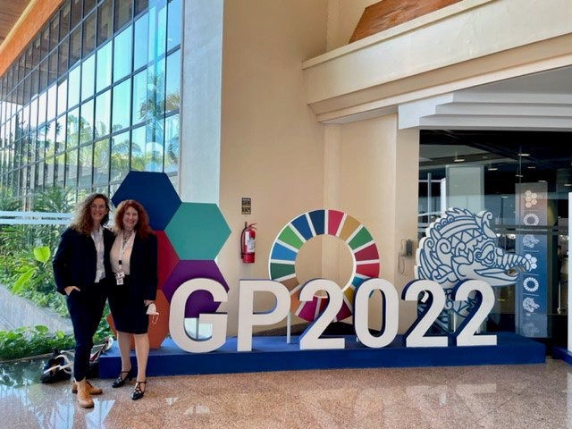
TRI COO Lorraine Schneider & CEO Andrea Davis at the 2022 United Nations Disaster Risk Reduction Conference in Bali, Indonesia. TRI supported the planning of the public-private sector cohort.

Presenter
2025-04-25 18:51:31
--------------------------------------------
A: Andrea to kick off, share her why for starting TRI and introduce Clinton.

Presenter
2025-04-25 18:51:32
--------------------------------------------
A: Andrea to share her Walmart experience to tee up Clinton looking for automation solutions.

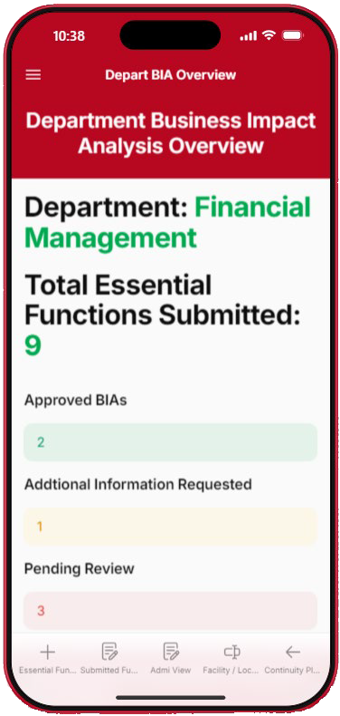
Background

→We are partitioners, coming from Fortune 1 and were frustrated with the complexity and price of emergency management and continuity tools on the marketplace.
→Covid-19 changed how emergency management continuity planning has traditionally been done.
→Organizations need a simple, cost- effective solution to support their planning needs.

Presenter
2025-04-25 18:51:33
--------------------------------------------
A: Regardless if we are working with a rural county, a large metropolitan utility or a Fortune 500 company, we noticed that our clients had similar needs and challenges. Requirements regardless if they are governmental or legal, focus on creating documents instead of the process and quickly become dated as soon as we produced them. We wanted to create a more impactful experience for our clients to make their assessments and plans more Imbedded into their day-to-day processes.

Problem Set: How Do You Modernize Your Planning Process with No Funding?

Needs:
- Automated document update and review processes.
- Real-time team collaboration, promoting effective communication and information sharing.
- Tailored workflows that align with the organization’s unique needs and considerations.
- Data-driven insights and reports, aiding in performance assessment and decision-making.

Risk Assessment M at ri'x



LO1W IMPACT

SEVERITY

MAJOR

EXTREME
LOW
M OIDERATE
••
MODERATE IMPACT

MAJOR

EXTREME

Risk
Rating Key
- Low/No Injury • PotenHal Injury
- Localized Damage • Regio nal Damage
• Less Thain $1,000 los t, • $ 2 , 000 $5 , 0 00 lost
- 1 Day (Or Less) Outage • 1 5 Day Outage
- Likely Injury
- Widespread Damage
- $5,000 $20,000 Lost
- .5 20 Day Outage
- Likely ln,jury / Deat h
- Complete Asset lo 1s:s
- $20 ,000 $100 ,0 0()1 llost
- 20--60 Day Outage

Presenter
2025-04-25 18:51:33
--------------------------------------------
A: Our first step was to create a series of generalized templates that we could walk each client through. Here is an example of a simple risk assessment we put together.


IMIPROBABLE
=================::::::::
LOW
MODERATE --
::::===============:::::::::::===============::::::::
MODERATE
MAJOR
EMceptional Occurrence -
Once E, very 25 Years

, pQSSIIBLE
LOW
MODERATE
MODERATE
---
l n& equent Occurrence -
Once IE, very 1, 0 Years

L KELY
l n firequ ent Occrurrence -
once E, very 5 Years

))11((THE RESILIENCY INITIATIVE

Impact Analysis-Sample Workﬂow

Informa�on Gathering:

Func�on

Finance Payroll

Impact if Disrupted

Employees will not receive weekly pay

Dependencies

Key 3rd Par�es

Qualita�ve / Quan�ta�ve Impact:

Risks
Document signiﬁcant risks that could impact cri�cal func�ons.

Human Resources
opera�ons

Administra�on opera�ons

Human Resources

Delayed Hiring Incomplete
Background Checks

Key Resources Needed

Equipment Facility

Recovery Time Objec�ve
Determine the maximum amount of �me the business can tolerate func�on disrup�on.

Financial Loss

Department

Finance

Human Resources
Customer / Brand
Opera�ons Revenue Health / Safety
If possible, quan�fy and document ﬁnancial impact of func�on disrup�on.

Cri�cal Major Moderate Minor

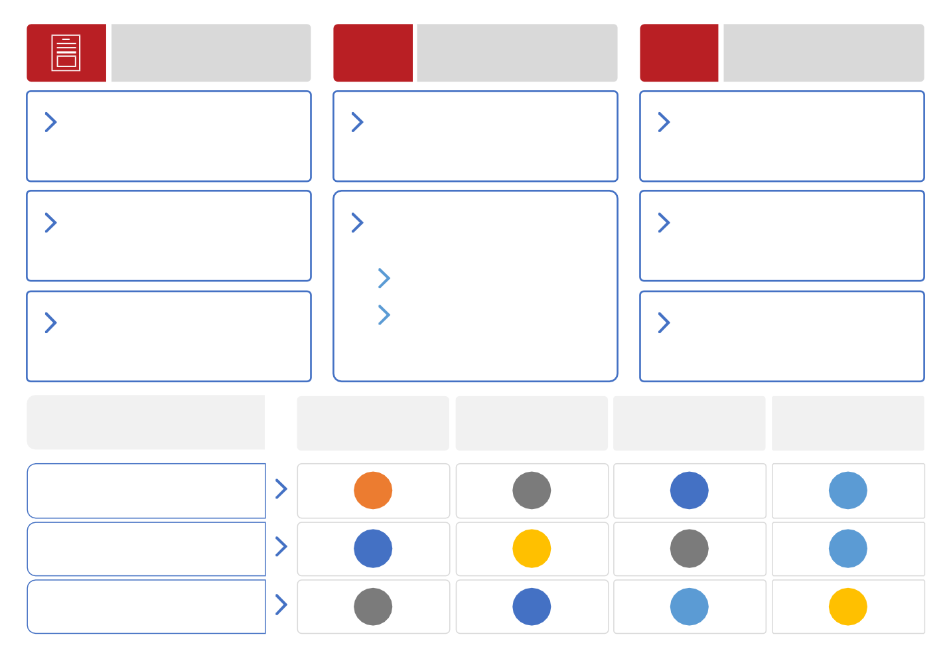
Presenter
2025-04-25 18:51:34
--------------------------------------------
A: here is an example of a templated process we created to help define an organizations critical functions and help them determine their recovery time objectives. We used this process along with organizational surveys and department level interviews. The data captured helps identify critical processes, systems, and services that, if interrupted, could have severe consequences to personnel, equipment, infrastructure, technology, information, and supply chain. We will typically create process diagrams that outline the interconnectedness of various functions within the organization. Identifying dependencies among departments, facilities, systems, and personnel. This will help visualize how disruptions in one area could affect others and inform the prioritization of essential functions. Next step is usually plan creation normally putting all this dynamic information into a static document and we all know what happens to that static document, its obsolete the moment it is printed so we wanted to provide a different solution to our client. Pivot to Clinton.
Administra�on

Standard ra�ng scale

How did I get here?
- Director of Physical Security Technology
- Director Risk Intelligence
- Director of Global Preparedness and Business Continuity
- Sr. Manager – Technology and Innovation

- Director of Physical Security Technology
- Director Risk Intelligence
- Director of Global Preparedness and Business Continuity
- Sr. Manager – Technology and Innovation

How did I get here?

Background

- Director of Physical Security Technology
- Director Risk Intelligence
- Director of Global Preparedness and Business Continuity
- Sr. Manager – Technology and Innovation

How did I get here?

Lack of Background
- No Security or Emergency Management background
- Not a software
engineer or developer
Opportunities

- Director of Physical Security Technology
- Director Risk Intelligence
- Director of Global Preparedness and Business Continuity
- Sr. Manager – Technology and Innovation

How did I get here?

Lack of Background
- No Security or Emergency Management background
- Not a software
engineer or developer
Luck Opportunities
- American Airlines to Walmart
- Quickly pulled into the
world of security

- Director of Physical Security Technology
- Director Risk Intelligence
- Director of Global Preparedness and Business Continuity
- Sr. Manager – Technology and Innovation

How did I get here?

Lack of Background
- No Security or Emergency Management background
- Not a software
engineer or developer
Luck Opportunities
- American Airlines to Walmart
- Quickly pulled into the
world of security
Execution
- Institutional Knowledge
- Appreciation for the
culture
- Ability to navigate bureaucracy
- Gain support and funding
Resourceful
- Maximize the use of
existing tools
- Align solutions to business opportunities
- Willingness to work on the projects that no one else wanted to do

Walmart Business Continuity Rebuild

- Binder-based program
Development
  - 15+ Countries
Result

- Expensive consultant
- Little to no awareness
- No executive support

Assessment
- Removed the consultant
- Developed policy
- Tailored program to
Walmart
- Basic Word/Excel templates
- Developed marketing and training
- Freedom within a
framework
- 2 Years rollout
- 6 Team members +
consultant support

Implementation
- Global awareness
- Low and limited participation
- Difficult to maintain
- Expensive to manage

Transition to Automation

Downside of the Basic Template Program
→ Increased administrative burden
→ Number of staff needed
→ Volume of task
→ Stakeholder turnover without notice or
handoff
→ Poor maintenance task initiation and compliance
→ Limited understanding of program goals
→ Limited ability to assess the global program
→ Continued need for significant BC headcount
→ Manual plan activation process
Technology Implementation
→ Structured program profiles
→ Automated/Integrated user access
→ Real-time program compliance monitoring
→ Embedded training and awareness tools
→ Automated maintenance cycle and task initiation
→ Flexible workflow design
→ Integrated mass communication and notification workflow

Transition to Automation

Cost of Automation
→ Dedicated internal IT staff to manage
development and implementation
→ Significant training for the program
administrators
→ Multi-year rollout timeline
→ Implementation cost $300K+
→ Subscription costs $200K annually
  - Program maturity
  - Program awareness
  - Annual cost $
  - Plan usability
  - IT dependency
  - Program compliance and health
  - Program complexity

    - Administrative burden
    - Program staff
    - Recovery time
    - Stakeholder task

Presenter
2025-04-25 18:51:41
--------------------------------------------
C: kickoff by sharing a personal story from your career to add to your why of creating the App/Workplace. Transition into sharing your journey of exploring open-source options. Add logo’s here.

Los Angeles County Sanitation COOP


Similarities in Approach and Complexity
→ One of the largest and most complex
sanitation programs in the world
→ 27 administrative districts managing multiple
critical infrastructure sites:
→ Wastewater Treatment Sites
→ Landfills
→ Power Generation
→ Thousands of miles of sewers
→ Recycle centers
→ 1500+ Employees
→ No Continuity or EM Staff

Presenter
2025-04-25 18:51:42
--------------------------------------------
C: kickoff by sharing a personal story from your career to add to your why of creating the App/Workplace. Transition into sharing your journey of exploring open-source options. Add logo’s here.

Los Angeles County Sanitation COOP
Project Requirements
→ Lead BIA across all administrative and
operational functions
→ Develop the district’s first COOP program
→ Develop and lead the organization-wide training and program awareness
→ Develop and lead tabletop and functional
exercise programs
→ Create and deliver the COOP program using
Microsoft Word and PDF templates

Finding Middle Ground

Can we develop and implement a solution that allows for increased automation and decreased administrative burden with limited budget and IT resources?
DCoswt nosfidAeutoofmthaetioBnasic Template Program

→ IDnecdreicaasteeddAindtmerinnaisltIrTatsitvaeffBtuordmeannage
de→veNloupmmbeenrtoafnsdtaimff pnleeemdeendtation
→ Sig→niVfioclaunmt etraoifntiansgkfor the program
→ Satdamkeinhiostldraetrotrusrnover without notice or
handoff
→ Multi-year rollout timeline
→ Poor maintenance task initiation and
→ Icmomplpelmiaenncteation cost $300+

→ SLiumbistcerdiputinodnecrsotsatnsd$i2n0g0oKf apnronguraalmly goals
Presenter
2025-04-25 18:51:42
--------------------------------------------
C: Focus on the how you went about creating templates. Share the cost to get certified and the time it took you for the certification. Give examples of time commitment for each. Make sure to mention their cyber security standards.
→ Limited ability to assess the global program
→ Continued need for significant BC headcount
→ Manual plan activation process


Presenter
2025-04-25 18:51:43
--------------------------------------------
C: Share what you built for LA Sanitation and how it has transformed how they do business. Highlight how you will now be focusing incident management.

Low/No–Code

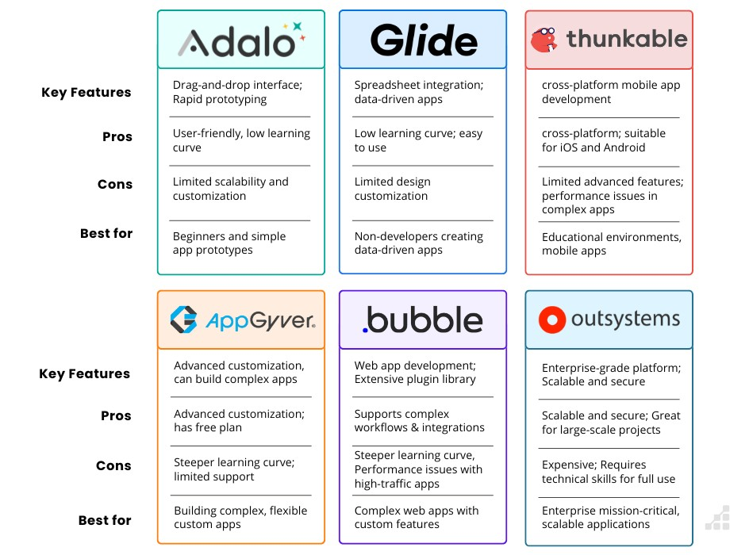Platform Comparison


Glide Application Development

Glide Application Development

Presenter
2025-04-25 18:51:49
--------------------------------------------
C: Share any closing thoughts; if ready, share about the marketplace and we can have a QR code that links to it.
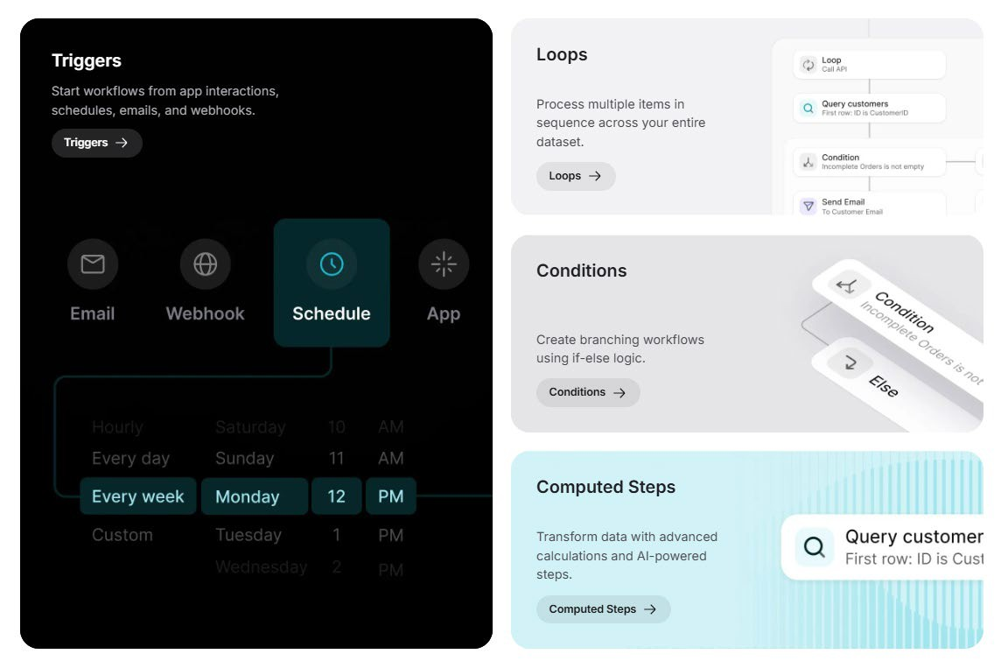Workflows
Add content

Presenter
2025-04-25 18:51:50
--------------------------------------------
C: Share any closing thoughts; if ready, share about the marketplace and we can have a QR code that links to it.
Integrations

AI Tools

AI Tools
→ No code platforms have made developing and integrating AI solutions into your application
extremely easy.
→ Response and recovery plan Generator
→ Incident log summarization
→ Internal and external crisis comms assistant
→ Role assignment based on skill set and availability
→ Risk register summarization and recommendations
→ Service request assistant
→ Recovery plan evaluator



))I((THE RESILIENCY INITIATIVE

AI Tools

AI Tools



Platform Comparison

Getting Started with No/Low Code
→ Plan your
development process
→ Brainstorm
workflows
→ Invest in
training or
certification
→ Start small
→ Use free Trials
→ Research
platforms
→ Understand capabilities and Limitations

→ Consider and | → | Communicate | → | Research possible | → | Understand IT → |  | Leverage | → Create
document |  | with stakeholders |  | integrations with |  | security |  | analytics and | supporting

different user types and profiles
Document
requirements
→
Assess the
existing data you might need
→
→ Identify others who can provide testing and quality control support
existing technology
→ Integrations can require separate subscriptions or additional fees
requirements
→ Gather any relevant
assessment details.
reports to
monitor usage
documentation

Getting Started with No/Low Code

→ Subscription costs can | → | Simple applications | → | Several platforms offer | → | Certified development
range from $50 to over |  | can be developed in |  | self-paced training |  | agencies like TRI can help
$1,000 monthly |  | less than a week |  | programs or |  | you develop and manage

→ Pricing is typically based on the number of users and updates
→ Several platforms offer free versions
→ Most allow subscribers to publish several applications at a time
→ More complex applications can typically be developed in 2 – 4 weeks
certifications
→ There is a large active developer community that generates instructional content on YouTube and other platforms
your application
→ Agency fees vary based on the complexity of the project, typically starting around $2,000 to $15,000

Presenter
2025-04-25 18:52:01
--------------------------------------------
C & A:

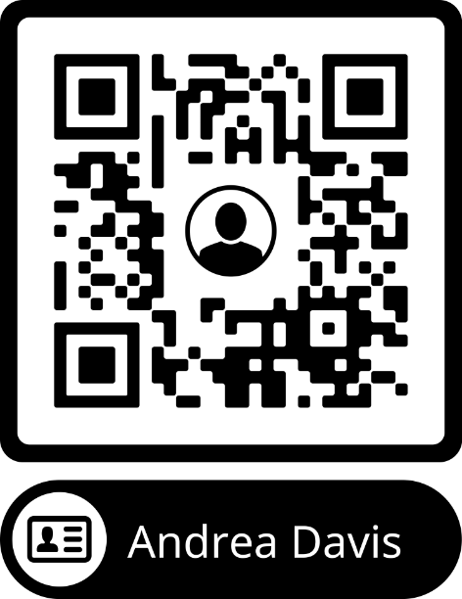Questions?

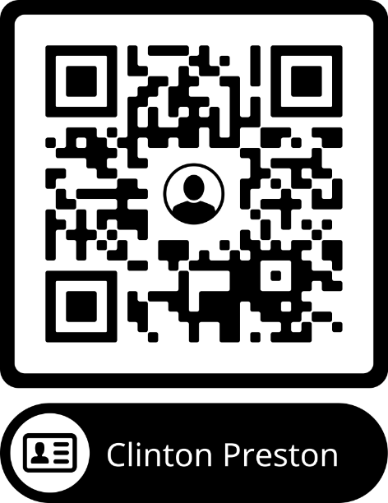

The Resiliency Initiative
Plan Better. Recover Quicker

